

Module Title: | Machine Learning for Business
Assessment Title: | CA1
Lecturer Name: | Dr. Muhammad Iqbal
Student Full Name: | Catalina Gonzalez
Student Number: | 2024458
Assessment Due Date: | 3rd March 2025
Date of Submission: | 20th April 2025

Canopy Growth Corporation (CGC)

Part I
Objective:
The purpose of this analysis is to examine how Canopy Growth Corporation's (CGC) share price has fluctuated over time and to determine the market factors that may have influenced these fluctuations. This dataset focuses on CGC's financial data, obtained from Yahoo Finance, in order to apply clustering techniques and time series models.

The main objective of this study is to segment the market using clustering algorithms and to forecast future stock prices using an ARIMA model. To this end, a detailed analysis of CGC share price fluctuations will be carried out to identify whether there is an upward, downward or stable trend in their behaviour over time. This approach will allow an assessment of how CGC's shares have performed in relation to general market cycles.

In addition, it will seek to predict the future behaviour of CGC's share price and assess its potential market performance, based on the results obtained through time series analysis.

Motivation:
The primary motivation for this analysis is to explore and understand the behavior of Canopy Growth Corporation's (CGC) stock price fluctuations over time. By examining historical price data, we aim to identify market trends that can provide crucial insights for making informed investment decisions. Specifically, the analysis will investigate whether CGC's stock price is following an upward, downward, or stable trend, and how it aligns with broader market cycles.
Additionally, the seasonality analysis will help uncover cyclical price patterns that reoccur over specific periods, such as quarterly or yearly cycles. Recognizing these patterns is essential for anticipating price movements driven by seasonal market dynamics or company-specific events such as earnings reports, product launches, or changes in regulatory environments.
The motivation behind incorporating clustering techniques is to segment the market into meaningful groups based on stock price behaviors, enabling a more tailored approach to forecasting and strategy development. By using ARIMA models for time series forecasting, we can project future stock price trends, offering investors a data-driven approach to estimate potential market movements.
Through this comprehensive analysis of CGC's stock price and its underlying factors, the goal is to empower investors with the necessary insights to make more strategic and informed decisions.

Dataset Description:
The dataset used in this analysis comes from Yahoo Finance and contains historical information on Canopy Growth Corporation (CGC) stock prices for the past five years.
- This dataset includes the following key columns:
- Date: The day the observation was recorded.
- Open: The stock's opening price on that day.
- High: The highest price reached during the day.
- Low: The lowest price reached during the day.
- Close: The closing price at the end of the day.
- Volume: The total number of shares traded that day.
This dataset is the basis for our analysis, allowing us to explore how CGC's stock has performed over time, identify potential market trends, and apply predictive models to estimate future prices.
Problem Domain:
The focus of this analysis is on studying the behavior of Canopy Growth Corporation (CGC) stock within a financial context. We want to understand the market dynamics that affect its stock price and how these influences can be modeled using statistical and machine learning techniques.
By analyzing historical stock prices, we seek to identify patterns and trends that help us predict how the stock will behave in the future. This is critical for making informed investment decisions, as predicting a stock's future behavior allows investment strategies and portfolios to be adjusted accordingly. The analysis focuses on how fluctuations in CGC's stock relate to broader market cycles and company-specific events.
By applying statistical methods such as the ARIMA model for time-series forecasting and clustering techniques for market segmentation, we can thoroughly examine the stock's performance and assess the associated risks and returns. These tools will allow us to have a clearer view of what to expect in the future and, therefore, make more accurate and informed decisions.
Implement Clustering Algorithms to Segment Data:
We will use clustering techniques to segment the market and discover groups of similar patterns in stock behavior. By applying algorithms such as k-means and DBSCAN, we will be able to identify time periods in which stock behavior follows similar trends. This will allow us to find patterns and make more accurate predictions based on different behavioral groups.
Apply Time Series Models to Predict Stock Prices:
We will use the ARIMA (Autoregressive Integrated Moving Average) model to forecast future stock prices based on historical data. The ARIMA model is well-suited to capturing patterns in time series, such as trends, seasonality, and past correlations, which will help us predict CGC's stock behavior in the near future.
Evaluating Models Using Performance Metrics:
To measure the effectiveness of the clustering and prediction models, we will evaluate their performance using standard metrics. For clustering, we will use indicators such as the Silhouette Index and the Davies-Bouldin Index to analyze the quality of the clusters formed. For the ARIMA model, we will use metrics such as the Mean Absolute Error (MAE) or the Root Mean Square Error (RMSE) to evaluate the accuracy of the price forecasts.
In the first stage of the analysis, we begin by thoroughly reviewing the raw data to ensure it is ready for further analysis. This starts with loading the dataset and verifying that all key columns are present. An important step here is to check that the date format is appropriate for working with time series. Next, we check the integrity of the data by looking for missing values. This step is crucial because missing values ​​can distort models and generate inaccurate results if not managed properly. Depending on the amount of missing data, we may decide to impute values ​​or even delete incomplete rows. This ensures that the dataset is well-structured and clean, which is essential for performing time series analysis and clustering effectively. With the data in the proper format, we can apply models correctly and obtain accurate insights into market behavior.

Part II- Clustering

Comparative Analysis of Clustering Algorithms:
In this analysis, two clustering algorithms were implemented: K-means and DBSCAN, which were evaluated using the Silhouette Score and the Davies-Bouldin Index.

Justification for the Selected Algorithms
Two clustering algorithms were chosen for this dataset:
K-Means: This algorithm was used to group the observations into a predefined number of clusters. It is ideal when you already have an idea of ​​the number of groups into which you want to divide the data.
DBSCAN: Unlike K-means, DBSCAN does not require a predetermined number of clusters. It detects clusters based on the density of the data points, making it useful for more flexible cluster identification.
Silhouette Score: It was used to measure the quality of the clusters formed. The Silhouette Score ranges from -1 to 1, with values ​​close to 1 indicating that the clusters are well-defined and separated.
Davies-Bouldin Index: This index measures the separation between clusters. Lower values ​​indicate better separation, meaning that the clusters are less overlapping.

Algorithm Analysis
The analysis of these two algorithms showed that K-means performed slightly better in terms of the Silhouette Score, indicating better quality of the clusters formed. On the other hand, DBSCAN performed better in terms of cluster separation, according to the Davies-Bouldin Index.

Clustering 01 - K-means
K-Means Implementation:
First, the Open, Close, and Volume variables were standardized using the StandardScaler, ensuring that each variable has a mean of 0 and a standard deviation of 1. This is essential to prevent scaling differences between variables from affecting the results. The K-means algorithm then divided the Canopy Growth Corporation stock price data into three segments.

To facilitate visualization of the clusters, PCA (Principal Component Analysis) was used to reduce the dimensions from three to two, generating a 2D graph. Cluster labels were added to the original DataFrame, making it easy to identify which group each observation belongs to.
Cluster Visualization:
The data is grouped using the K-means algorithm into three clusters, represented by points of different colors: red, blue, and green. These groups are visualized in a two-dimensional space using the two principal components obtained through PCA (Principal Component Analysis). The cluster centroids, marked in yellow, are located near the center of each group, representing the most representative points of each.
This graph makes it easy to observe how trading days cluster according to opening, closing, and transaction volume characteristics. It provides a clear visual representation of how the K-means algorithm segmented the data, allowing one to see the distribution of the data and how they cluster consistently according to these three key variables.

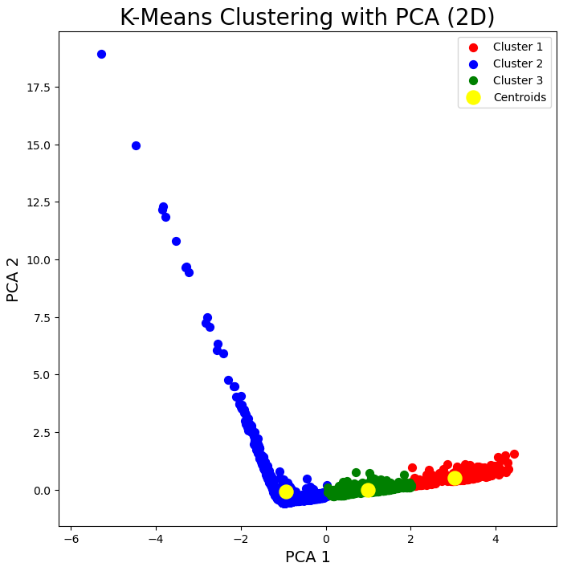

Analysis of the Elbow Method graph:
X-axis (Number of clusters): On the X-axis, you have the number of clusters (from 1 to 10). This is the parameter that is varied in the K-means algorithm to see how the inertia changes as the clusters increase.
Y-axis (WCSS - Within-Cluster Sum of Squares): On the Y-axis, you have the inertia, which is the sum of the squared distances from each point to the center of its respective cluster. The smaller the value of WCSS, the better the quality of the clustering, because the points are closer to their centroids.

Key observation - The Elbow:
As can be seen from the graph, the inertia decreases rapidly when going from 1 to 2 clusters. Then, the decrease slows down dramatically between the 2nd and 3rd cluster, indicating that adding more clusters does not significantly improve the segmentation.
The elbow occurs at the point where this deceleration is most evident. In this plot, the elbow appears to be at number 2 or 3, suggesting that the data is optimally segmented into 2 or 3 clusters.
The graph shows that adding more than 2 or 3 clusters does not result in a substantial improvement in data segmentation. This suggests that 3 clusters would be the optimal number of clusters to segment the Canopy Growth Corporation stock price data.
According to the graph, 3 clusters is the optimal number to segment the data, since after this point, the improvement in cluster quality (as measured by inertia) becomes very small.

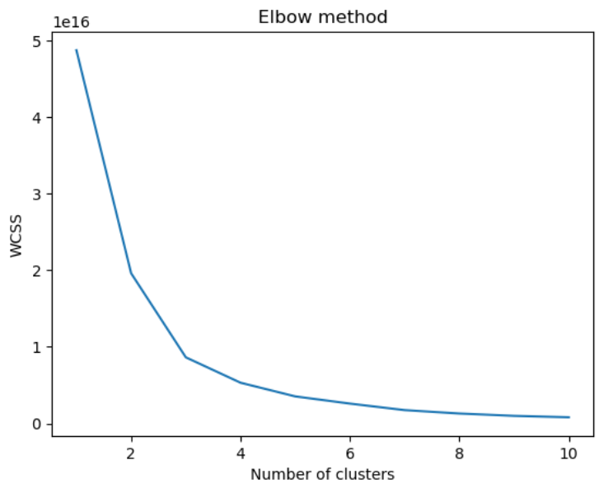

Analysis of the Silhouette Score graph:
X-axis (Number of Clusters): On the X-axis, the graph shows the number of clusters, ranging from 2 to 10. The number of KKK clusters is the parameter we are adjusting in the K-means model to observe how the Silhouette Score varies.
Y-axis (Silhouette Score): On the Y-axis, the graph shows the Silhouette Score, a metric that measures how well grouped the points are within a cluster. The Silhouette Score ranges from -1-1-1 to 111:
A value close to 1 indicates that the points are well grouped, i.e. the clusters are compact and well separated.
A value close to 0 indicates that the points are on the boundaries between two clusters, suggesting that the clusters are not well defined.
A value close to -1 indicates that the dots are poorly clustered.
Key observation - The optimal number of clusters: In the graph, the Silhouette Score starts high when there are 2 clusters, but then decreases as the number of clusters increases. This suggests that the ideal number of clusters is 2, as this is where the Silhouette Score is highest.
Optimal KKK value: According to the graph, the optimal number of clusters is 2. This can be confirmed because the Silhouette Score is higher for 2 clusters than for the other KKK values.
According to the Silhouette Score, the optimal number of clusters to segment the Canopy Growth Corporation data is 2.
Although the Elbow Method graph suggests that the optimal number might be 3 (based on inertia), the Silhouette Score suggests that 2 clusters would be the best choice, as this number provides the best segmentation quality in terms of distance between points and cohesion within each cluster.
The Elbow Method and the Silhouette Score offer slightly different perspectives:
The Elbow Method suggests that 3 clusters might be the ideal, as inertia decreases more slowly after that point.
The Silhouette Score suggests that 2 clusters would be the most optimal number, as it maximises the quality of the clustering.
Consider the silhouette score as the main metric for choosing the number of clusters in this case, as it provides a clearer assessment of the quality of the clustering. However, it is important to also consider the visual analysis and the purpose of the cluster to make a more informed decision.

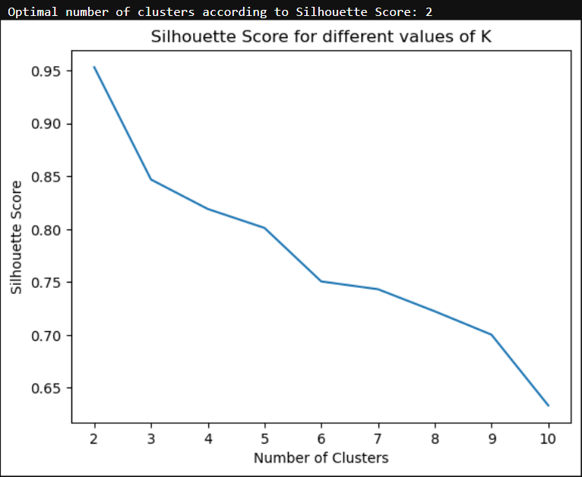

DBSCAN Chart Analysis
The chart generated by DBSCAN shows how the dots are clustered according to the Open and Close price of Canopy Growth Corporation shares. The different colours in the graph represent the clusters identified by the algorithm, while the noise points, which do not fit well into any cluster, are labelled with the value -1.
DBSCAN is a density-based clustering algorithm that does not require defining the number of clusters beforehand. Instead, it clusters nearby points based on the density of points in the feature space. The key parameters of DBSCAN are:
eps: The maximum distance between two points to be considered part of the same cluster (in this case, 0.5).
min_samples: The minimum number of points needed in the vicinity of a point to be considered a cluster kernel (in this case, 5).
Analysis of the chart reveals that the points are clustered according to the relationships between the opening and closing prices. In addition, if some points are scattered or not clearly coloured, they may be labelled as noise. This may indicate that some data do not fit well into the clusters formed.
The chart also shows the dispersion of the points, suggesting a possible correlation between the opening and closing prices, which could be further explored with a correlation or regression analysis.
In conclusion, the DBSCAN chart visualises how the algorithm groups the data, identifying clusters and noise points. If many scattered points are observed, there might be outliers that do not fit well into the clusters.

The dendrogram shows the hierarchy of the clusters formed by the Agglomerative Clustering algorithm. In this case, the graph has 3 identified clusters (as per the title), and is a visual representation of how the points progressively cluster as distances are reduced.
Interpretation: The different colours in the dendrogram correspond to the clusters formed by the model. In this case, the three clusters are well defined, which means that the algorithm found clear groupings in the data.
Dendrogram cut: The cut is performed at the appropriate level to obtain 3 clusters, indicating that 3 clusters is the optimal number for segmentation, according to this visual analysis.

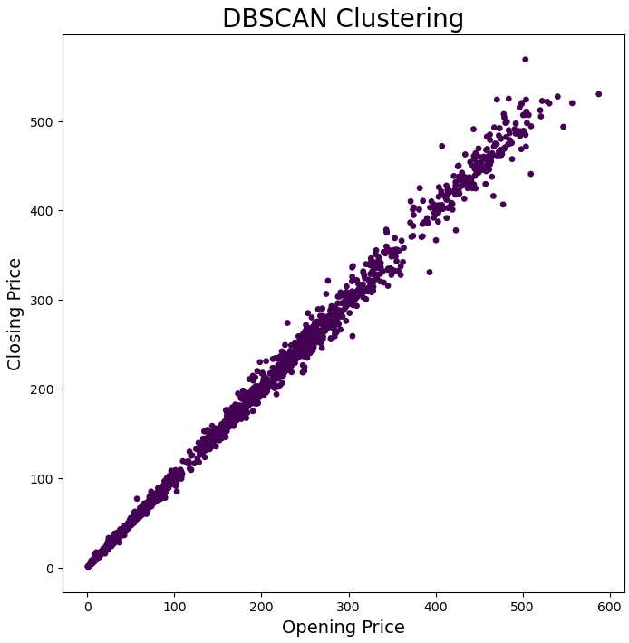

Analysis of the Davies-Bouldin Index and Silhouette Score Charts:
Davies-Bouldin Index:
The Davies-Bouldin Index measures the dispersion within each cluster and the separation between clusters. A low value of this index indicates that the clusters are compact and well separated.
In the graph, the lowest value of the Davies-Bouldin Index is at 3 clusters, indicating that 3 clusters are the best option according to this index.

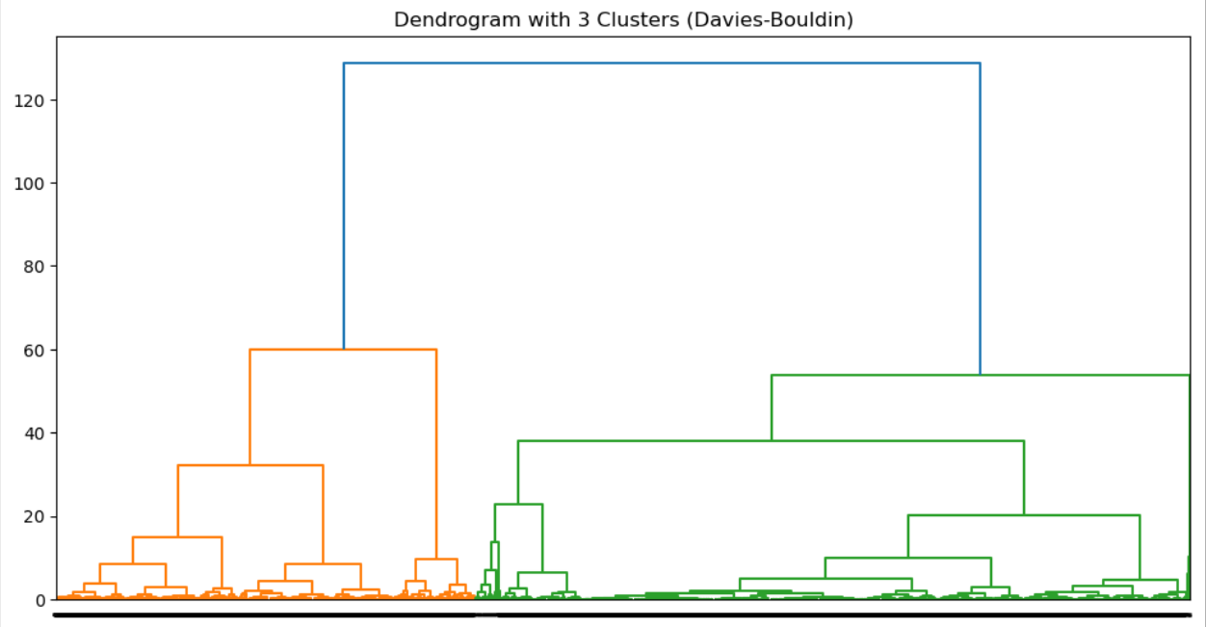

Silhouette Score:
The Silhouette Score measures how well points are grouped within their own cluster and separated from other clusters. A value close to 1 indicates that the dots are well grouped and separated.
In the graph, the highest Silhouette Score is observed for 2 clusters, suggesting that 2 clusters is the optimal number of clusters according to this metric.
Optimal Clustering Results:
Optimal number of clusters according to Davies-Bouldin Index: 3 clusters. The index shows that, with 3 clusters, the data are more tightly clustered.
Optimal number of clusters according to Silhouette Score: 2 clusters. The Silhouette Score shows that the quality of clustering is better with 2 clusters.
The Davies-Bouldin Index and the Silhouette Score give slightly different results. While Davies-Bouldin suggests that 3 clusters is ideal, the Silhouette Score suggests that 2 clusters would be more appropriate. Both methods are based on different principles to assess the quality of clustering:
Davies-Bouldin focuses on the separation and dispersion of clusters.
Silhouette Score evaluates the internal quality and separation of the clusters.
Dendrogram with 3 clusters (Davies-Bouldin): The dendrogram visualises the hierarchical relationship between the points and shows how they cluster as the branches are cut. The 3 clusters identified appear to be well separated.
Davies-Bouldin Index and Silhouette Score plots: The plots clearly show how the metrics vary as the number of clusters is adjusted:
The Davies-Bouldin Index decreases dramatically at cluster number 3, suggesting that the clusters formed at that point are of good quality.
The Silhouette Score is higher for 2 clusters, indicating that the quality of clustering is better at that point.
For the Davies-Bouldin Index, the optimal number of clusters is 3, as this is where the index reaches its minimum.
For the Silhouette Score, the optimal number of clusters is 2, as this is where the highest value of the metric is observed.
Both metrics suggest that 2 or 3 clusters are valid options depending on which one is prioritised (separation vs. cohesion of clusters).

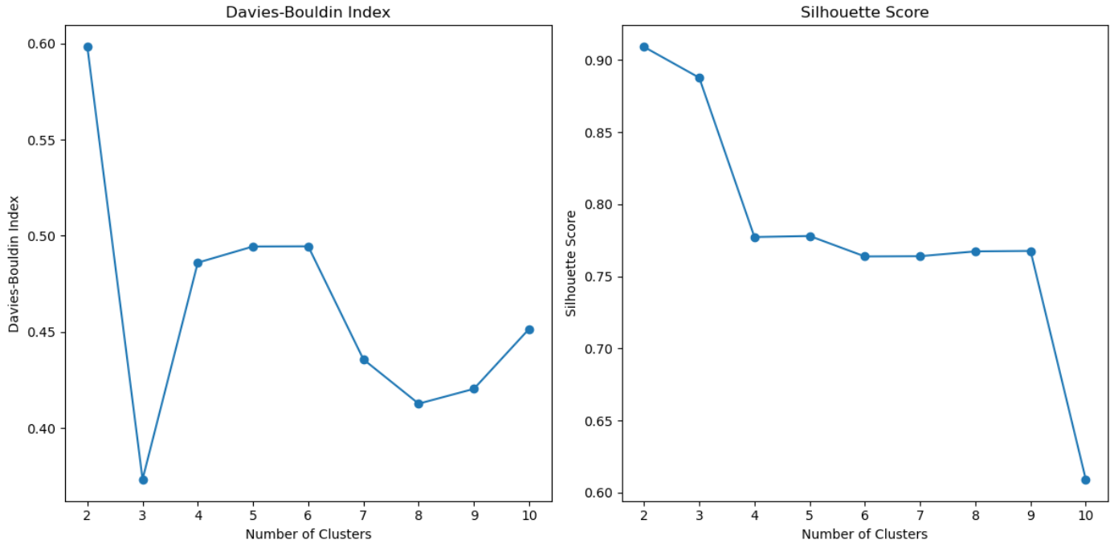

Part III - ARIMA model
ARIMA Model:
The ARIMA model appears adequate for capturing closing price dynamics, although future predictions may be less reliable due to the volatile nature of the data.
Autocorrelation: High autocorrelation suggests that closing prices are strongly influenced by past values, which is a good indication that the ARIMA model is appropriate.
Model Evaluation: The AR and MA coefficients show that past relationships are significant in predicting current prices. However, the sigma2 value indicates that there is considerable variability in prediction errors.

Closing price time series chart:
The chart shows how the closing price of Canopy Growth Corporation shares has changed over time. It shows that there are significant fluctuations in prices, with peaks and troughs, which may be related to major events in the market or in the company.
The general trend appears to be volatile, with large rises followed by falls. This is common in share prices of emerging companies or in markets with high uncertainty.
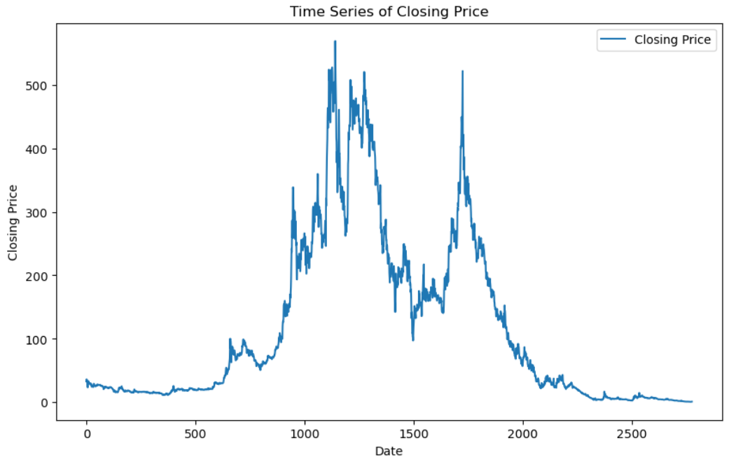

Autocorrelation (ACF) and Partial Autocorrelation (PACF) charts:
Autocorrelation: The chart shows how closing prices are correlated with their own past values. In your chart, there appears to be a high correlation between the values of the time series in the first few lags, indicating that past prices have a significant influence on current prices.
This chart shows the correlations between closing prices and their lags, removing indirect correlations. It can be seen that the partial autocorrelation becomes smaller after a certain number of lags, which can be useful for determining the order of the ARIMA model
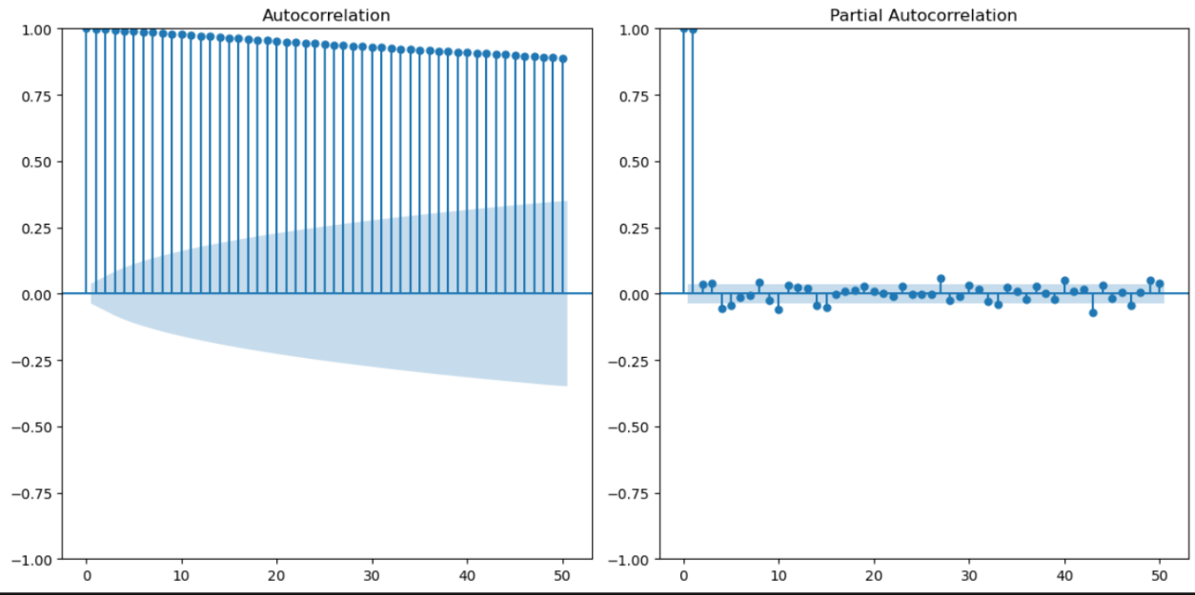

Graph of the original and differenced time series:
Differencing is done to make the time series stationary, removing the trend and making it more suitable for ARIMA modelling. The graph shows the difference between the original series (in blue) and the differenced series (in red).
The aim of this transformation is to make the series have a constant mean and variance, which is one of the key assumptions for applying the ARIMA model.
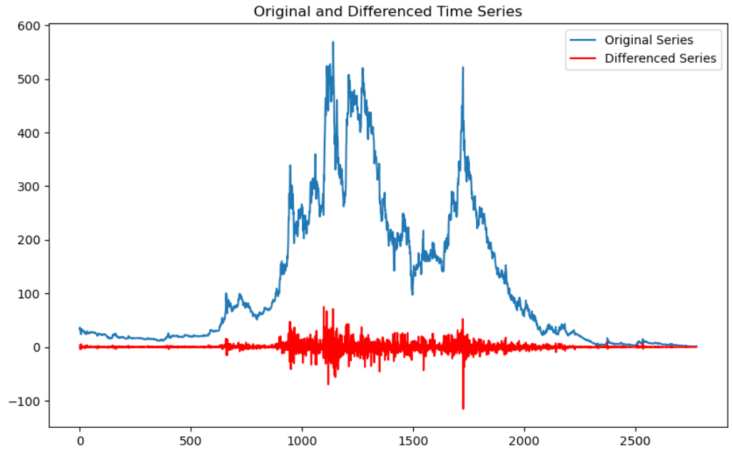

Results of the ARIMA model:
The summary of the ARIMA (1, 1, 1) model shows the fitted parameters:
AR (1): The coefficient of the autoregression is 0.18, indicating that the value of the closing price at time ttt is correlated with the value at t-1t-1t-1.
MA (1): The coefficient of the moving average is -0.23, suggesting that the differences between the closing prices at ttt and t-1t-1t-1t-1 affect the prediction.
sigma2: The error variance is 73.06, indicating the magnitude of the errors in the predictions.
AIC and BIC: These values indicate the quality of the model. A lower value of AIC and BIC suggests a better fitted model.
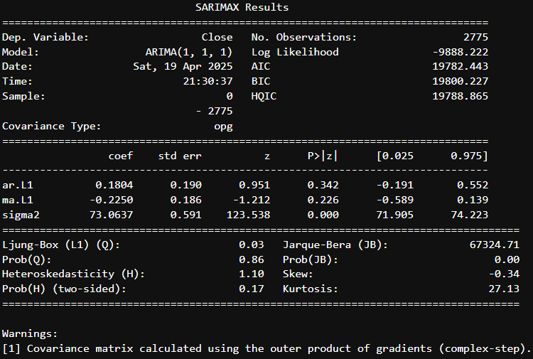

Predictions for the next 90 days:
The chart shows the closing price forecast for the next 90 days. The predictions are based on the fitted ARIMA model and are depicted in red, while the actual data are in blue.
The forecast appears to continue the trend of falling prices observed in the historical data, which is consistent with the time series trend. However, the prediction becomes less accurate as we move further into the future, which is typical in time series models.
